Name:___________________________ Date:____________ Block: __________________

Unit 3: Minerals
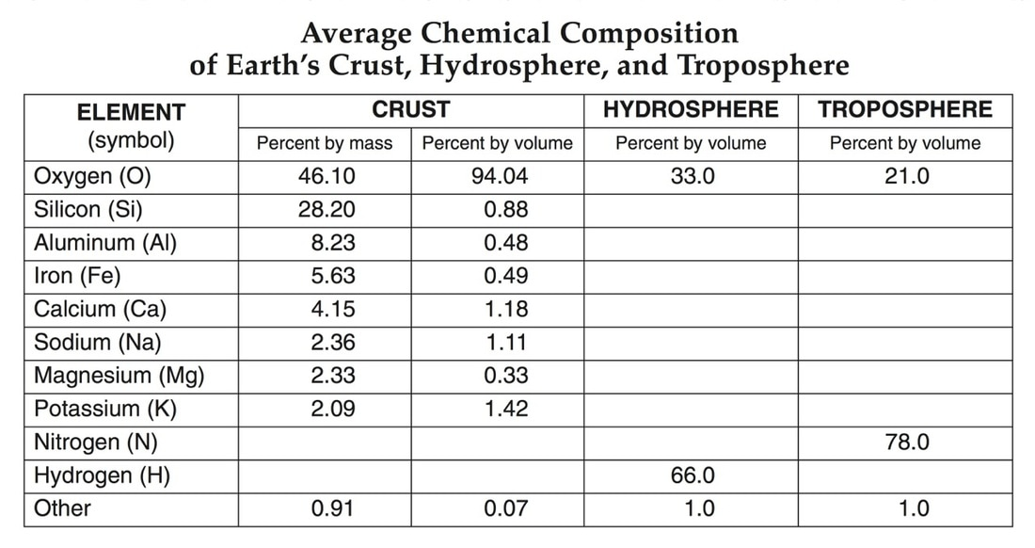
There are _______________ minerals found in the crust (pg. _______ of reference table will give common elements) but only a handful are commonly found!

- Minerals can be made of one element, ___________________ (ex: __________________),or ___________________ meaning a
Compound. (Example: ________________________)

- A Mineral: ________________________________________________________________________
__________________________________________________________________________________
__________________________________________________________________________________

All common minerals and their properties are listed on page ___________ of the reference table!

How Are Minerals Formed?

- 1.)________________________________________________________: atoms arrange themselves as magma/lava cools
Examples: ___________________________________
- 2.)_______________________________: Atoms rearrange themselves in already existing minerals when there is an increase in temperature and/or pressure.
examples: ___________________________________________
- 3.) ______________________________: mineral comes out of solution in supersaturated water with dissolved elements
Examples: evaporation of saltwater from oceans/lake beds form __________________
________________ deposits form from supersaturated water in oceans and in caves
Minerals are identified by:

- Chemical Properties/Composition: ____________________________________________________
(Example: Graphite is made of ________)
2.) Physical Properties: ___________________________________________________________________

*A minerals physical properties are always determined by the ___________________________________
________________________________________!!!!!!! (Key concept)

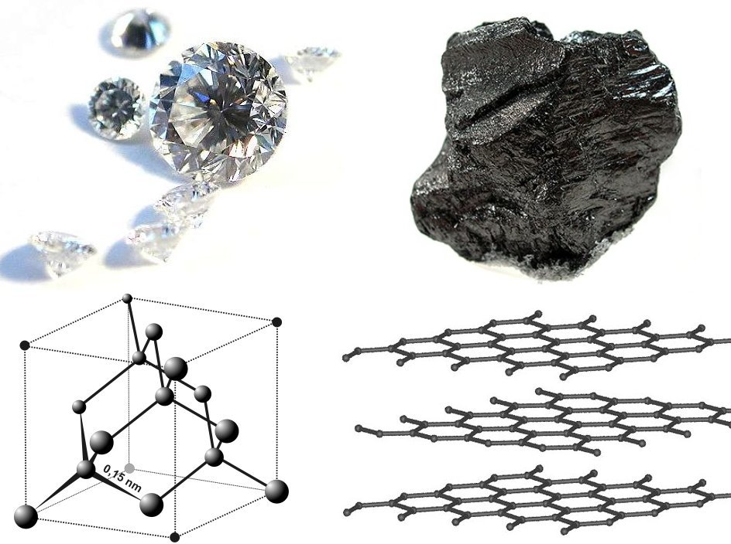
Diamond and Graphite have the same ______________ properties but have different _________________________ properties. This is because their internal arrangement (pictured left) is different.
Ex:
Color:

Hardness:

Mineral Identification by Physical Properties:

1.) Color- The problem with using color for identification is:
#1: __________________________________________________________
#2: __________________________________________________________
Examples:

2.) Luster- _______________________________________________________
The two types are:
1.) Metallic-

2.) Non metallic
a.)
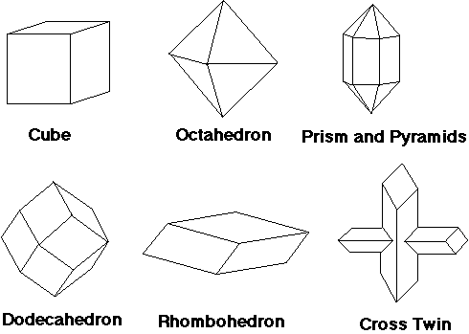
b.)
c.)
d.)

- Crystal “Habit” or Shape
Shape/Habit is ______ always shown by every mineral because minerals can grow in ________________ conditions. This means ________________ ____
________________ and perhaps not enough ________________ to grow!
Example, Quartz:
Typically shows not habit, but if grown in a perfect environment will grow into a _____________ shape.

4.) Streak- The _________________ of a mineral’s _________________left behind after scratching a “_____________” (unglazed porcelain tile)
Note: If a mineral is harder than the streak plate will it leave a color behind? __________________
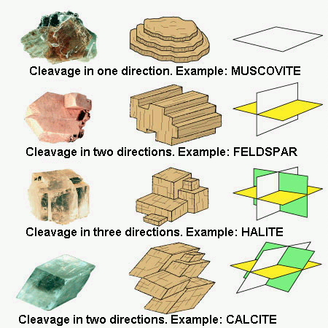
5.) Breakage of a Mineral: always look on the _______________ of minerals to distinguish this property!

a.) Cleavage:

b.)Fracture:

*Note that some minerals will show both forms of breakage, ____________ always dominates!

6.) Hardness (____________________________)
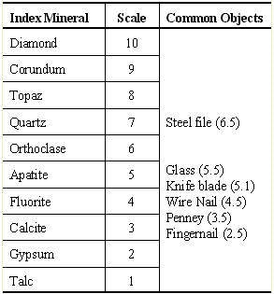
- A mineral’s ________________________ to being ______________________
- Measured on a scale from _________ to __________
- A mineral is said to be ___________ if it scratches ______________
(hardness equal to or greater than 5)
- A mineral is said to be ______________ if it can _______ scratch glass (hardness less than 5)

Other special properties of minerals:

1.) Reaction with Acid: Some minerals will bubble with acid
Mineral Ex: ______________________________

2.) Fluorescence which is when a mineral glows under black light
Mineral Ex:__________________________________

3.) Double Refraction which is where light bends through a mineral causing the image to ________________________ Mineral Ex:

4.) Smell: Mineral Ex________________________________

5.) Taste: Mineral Ex:_______________________________

6.) Magnetism: Some minerals contain iron which are magnetic and can be detected using a magnet

Mineral ex: ____________________

Mineral Groups:

1.) Silicates- are the most______________________ mineral groups and are made of which two elements?
_______________________ & ________________________
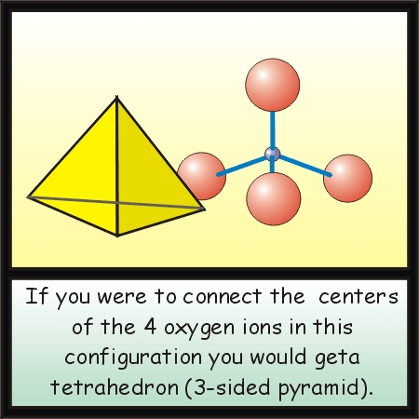
These atoms combine to form the silica-oxygen ______________________

Common silicate minerals listed in the ESRT are:

2.) Iron Oxides: these are mineral groups which contain large amounts of what element? ______________________
When these minerals combine with _________________ the result is___________________ which is known as “rust,” or looks reddish.

3.) Carbonates: Minerals containing a metallic element and a Carbonate compound ___________
Ex: ____________, or “CaCO3” Found in Limestone and Marble.
- These minerals break down with _______________ and acidic _________________

How many common uses of minerals can you identify using your ESRT pg. 16?

